Import Data using Transform Maps (Spreadsheet)
Phase 4: Project Planning Phase

1. Overview
The project is planned as a sequence of preparation, configuration, importing, transformation, validation and reporting activities. First the spreadsheet and target table are prepared. Next the Import Set and Transform Map are configured.
After field mapping, the transformation is executed and the resulting records are verified. Coalesce is then tested with repeated and updated data. Finally, reports and a dashboard are prepared.

2. Key Activities
- Prepare the spreadsheet.
- Create the Employee Test table.
- Create required fields.
- Create the Employee Import table.
- Load spreadsheet data.
- Create and configure the Transform Map.
- Run the transformation.
- Validate records.
- Test Coalesce.
- Create reports and dashboard.
3. Detailed Process
In this phase, the project work related to **Project Planning Phase** is carried out according to the overall ServiceNow project workflow. The activities are recorded in sequence so that the implementation can be understood and demonstrated clearly.

4. Expected Outcome
The phase should produce a clear and documented output that can be verified before moving to the next phase. The project remains focused on importing spreadsheet employee data into ServiceNow using Import Sets and Transform Maps.

5. Project Evidence / Screenshots
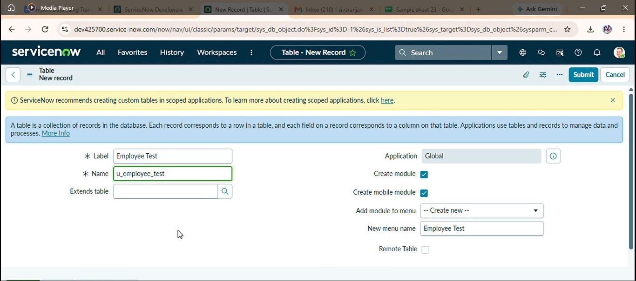

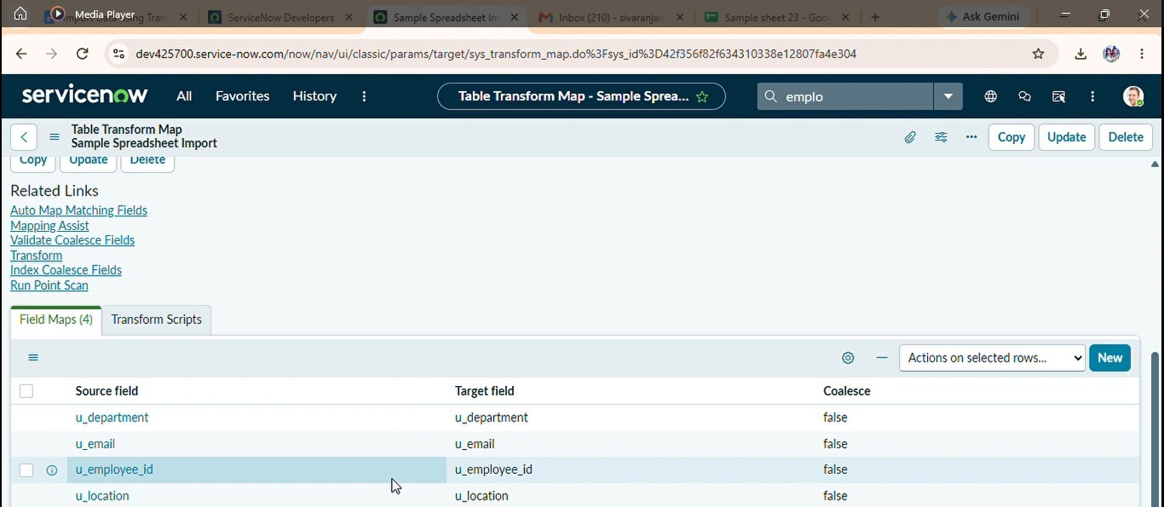

6. Phase Summary
Phase 4 completes the activities required for Project Planning Phase. The documented output and screenshots provide evidence of the project work and support the transition to the next phase.

